Refactoring

What's it?

Refactoring is the process of improving the internal structure of code without changing its external behavior. The goal of refactoring is to make code more readable, understandable, maintainable, and testable.

**And when apply it?**

- Once more changes (Updates )in code happen after developed.

- before adding updates or new features to existing code.

- is most commonly applied to legacy code. Legacy code is code that has been around for a long time and has been modified many times.

**What's diff between revamp and refactor ?**

evamping an app is the process of changing the look and feel of an app without changing its functionality. This can include changes to the user interface, the user experience, or the overall design of the app. Revamping an app can be done to improve its usability, to make it more visually appealing, or to keep it up-to-date with the latest trends.

|  |  |  |
| --- | --- | --- |
| Feature | Revamping | Refactoring |
| Changes | External appearance | Internal structure |
| Behavior | Unchanged | Unchanged |
| Purpose | Improve usability, visual appeal, or keep up-to-date | Improve performance, maintainability, or extensibility |
| Complexity | Less complex | More complex |
| Risk | Low risk | Medium risk |
| Time required | Less time | More time |

**How to start in refactoring for code? Or what's different ways to refactor?**

**There are more** techniques to refactor

But there are some useful tips:

## 1- Extract Method (split long functions) .

## 2- Replace Magic Number with a Symbolic Constant (convert hard code to variable ) .

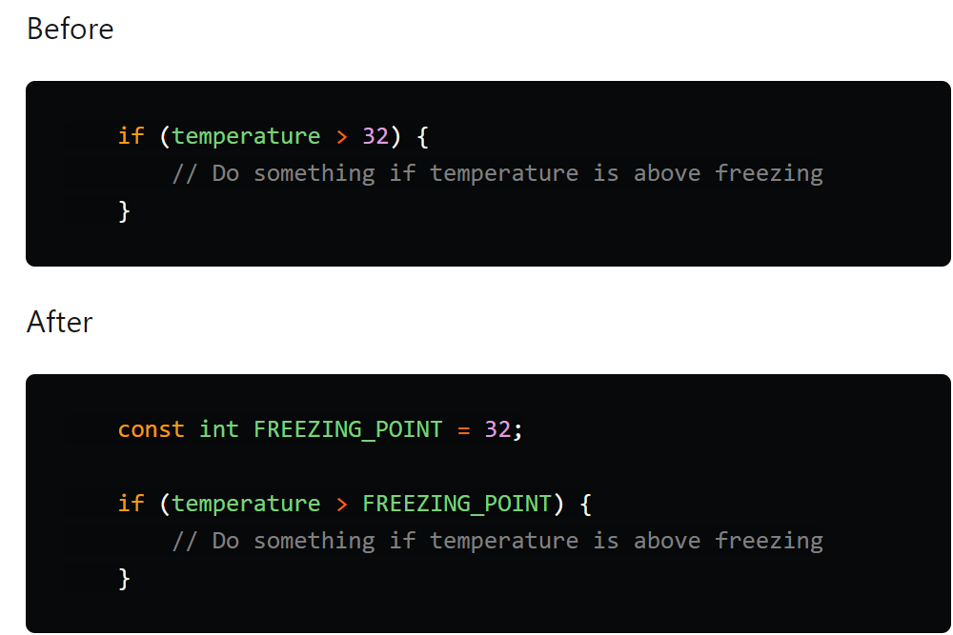

Or use Enum .

## 3- Merge Duplicated Code

If more Duplicated code use Function

or use interface or abstraction , inheritance .

## 4- Simplifying Methods

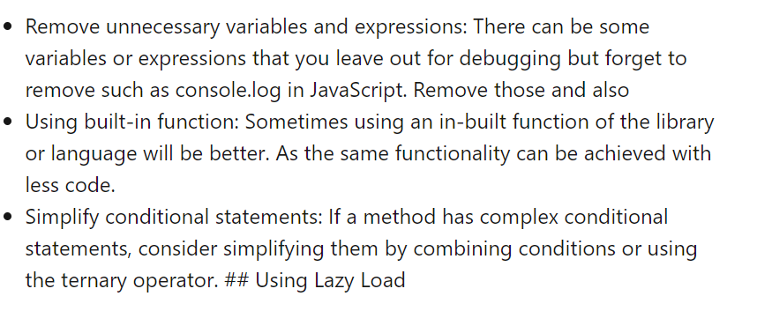

**For There are many approaches and techniques to refactor the code:**

### 1. Red-Green Refactoring

### 2. Refactoring by Abstraction

### 3. Composing Method

### 4. Simplifying Methods

### 5. Moving Features Between Objects 6. Preparatory Refactoring 7. User Interface Refactoring